1.Create a user that has temporary access for 5 days?

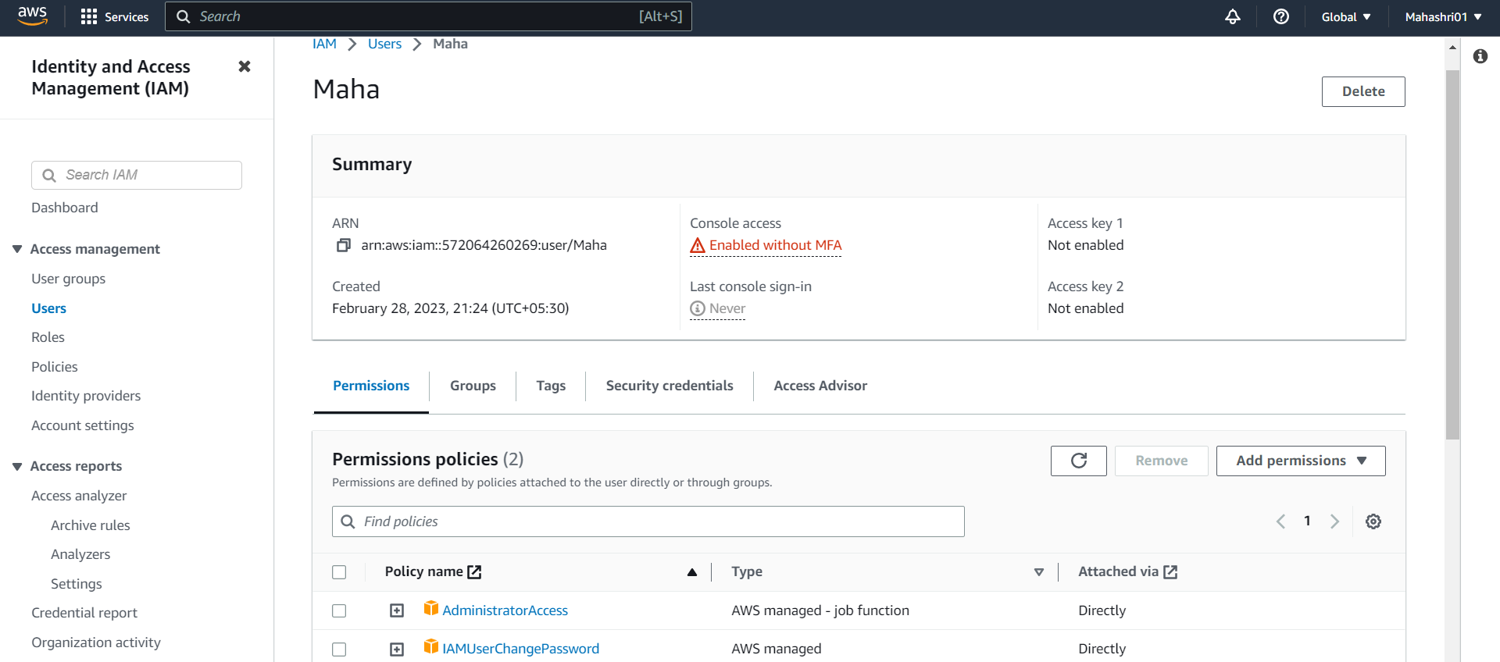

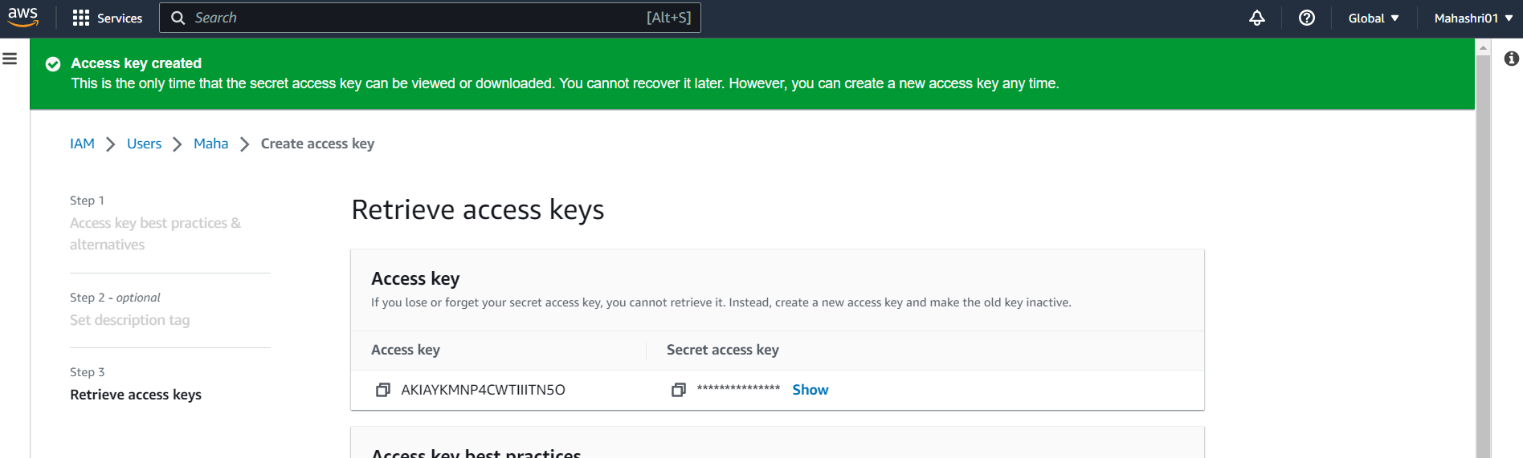

Note: Temporary access cannot be given for 5 days using the following command. The maximum limit is for 1.5 days.

“aws sts get-session-token --duration-seconds 432000”

432000= 5 Days

129600 = 1.5 Days = 36 Hours

Conditional access

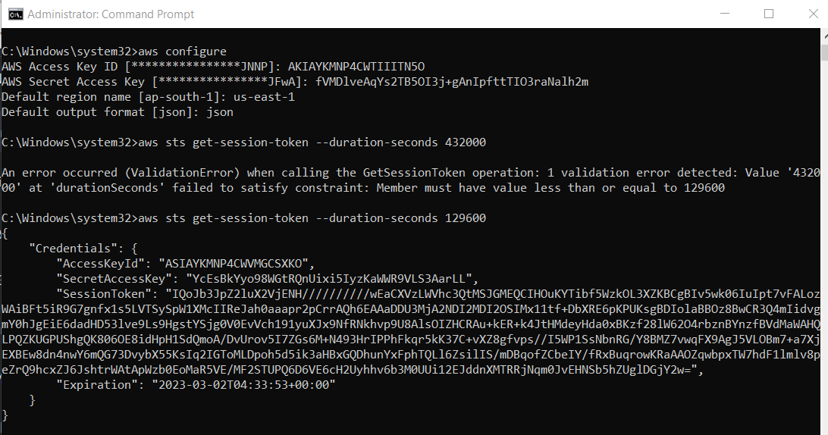

2.Store SQS message to DynamoDB table usingLambda function.

Create IAM role with the mentioned permissions

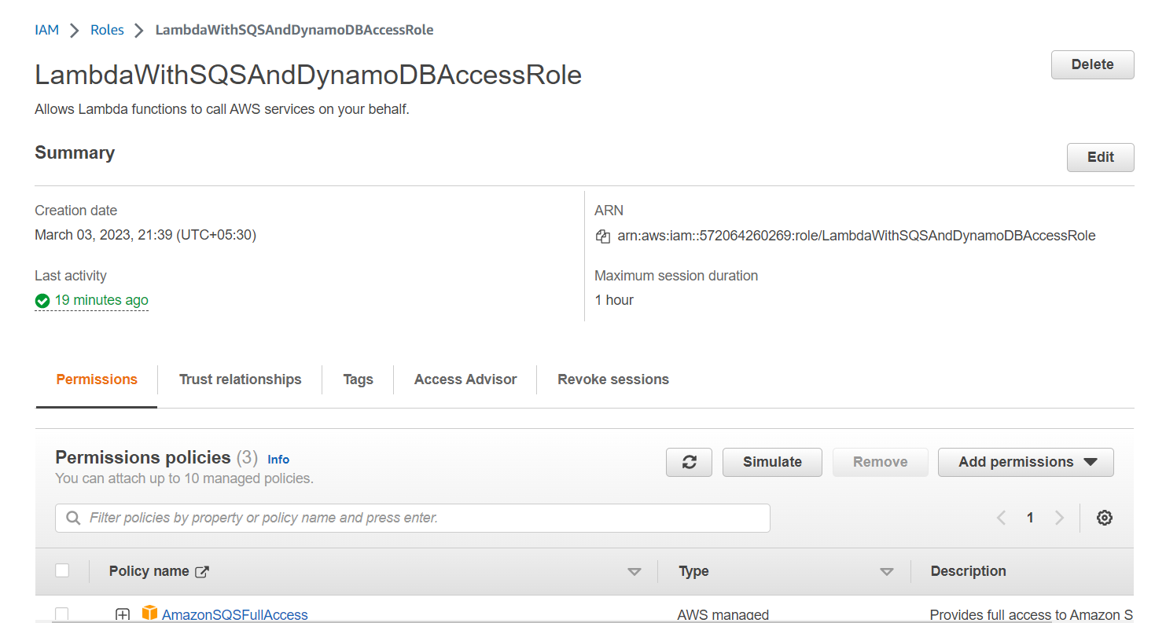

Permissions:

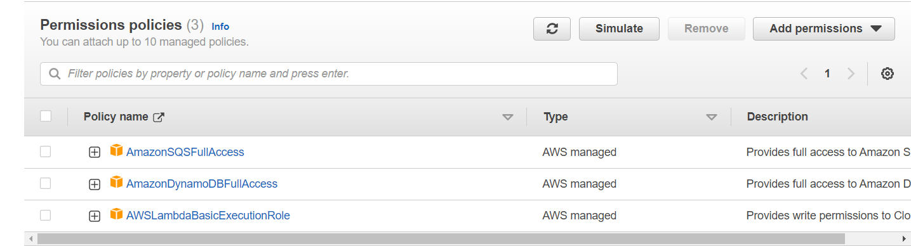

Create SQS Queue

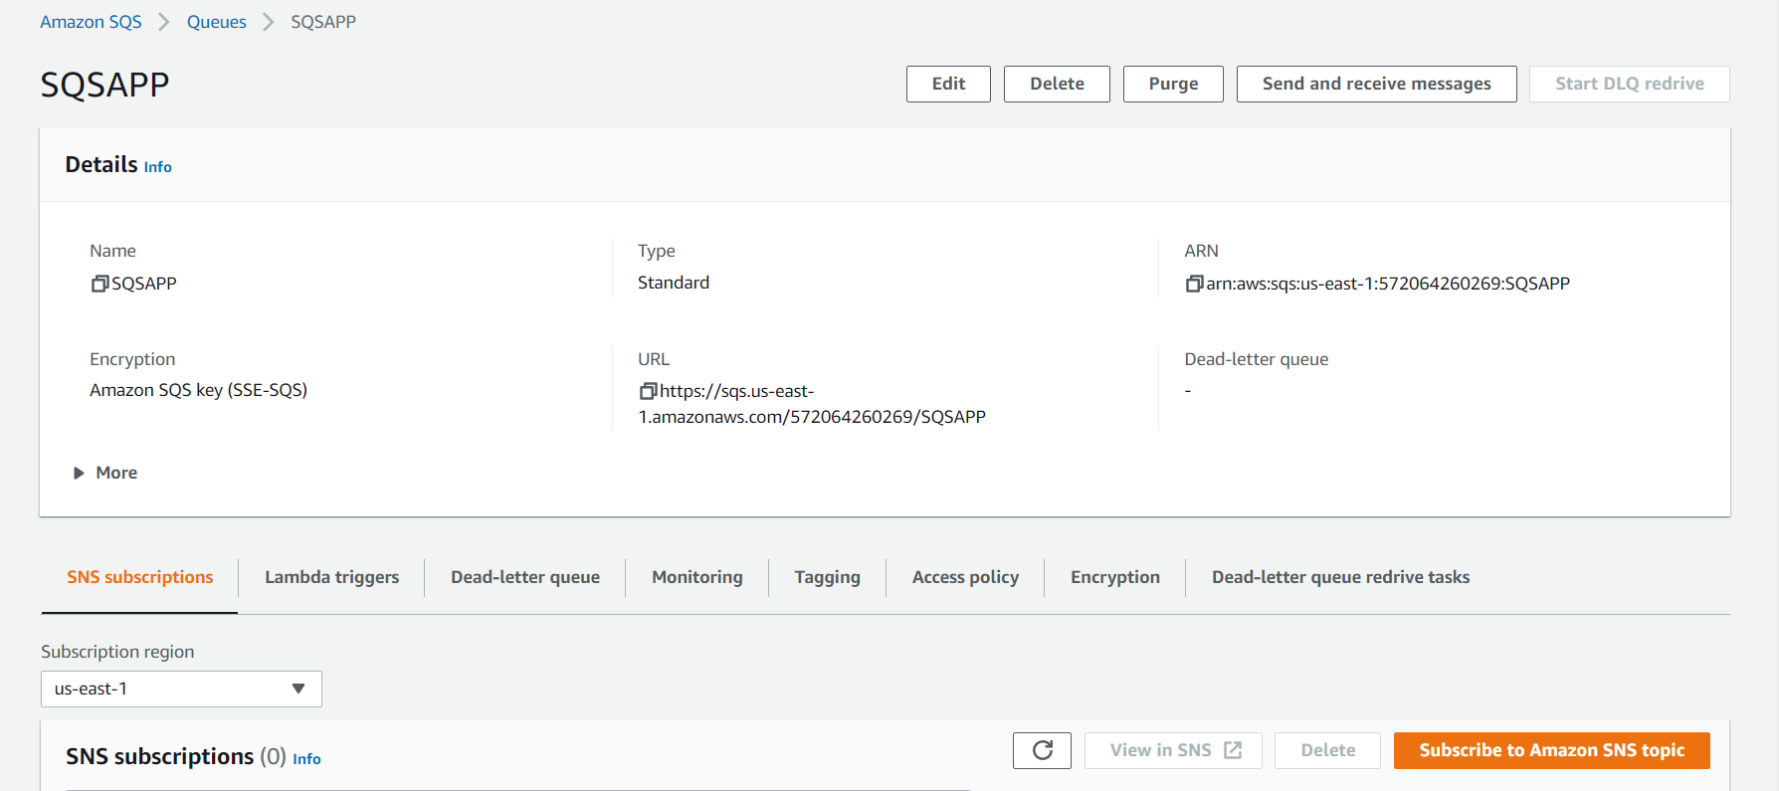

Create Lambda Function

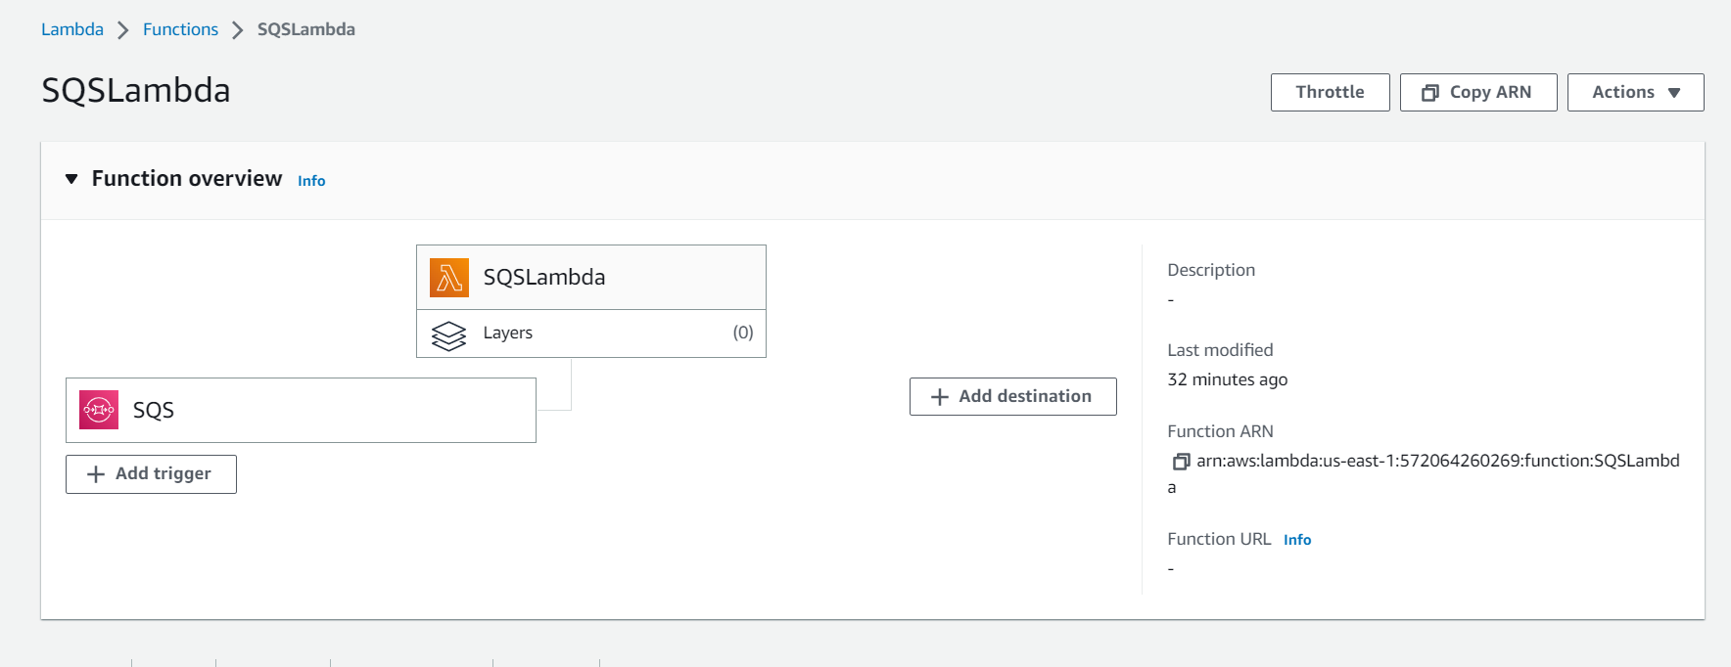

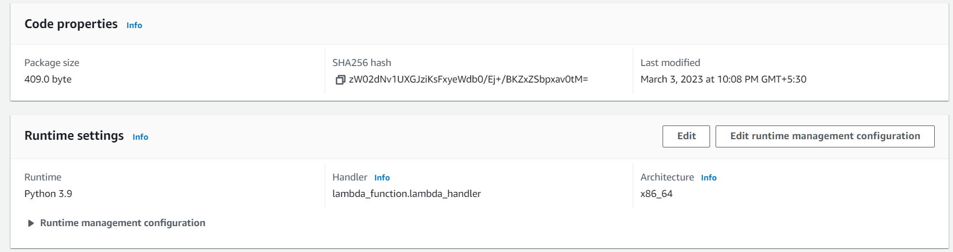

Deploy the below code

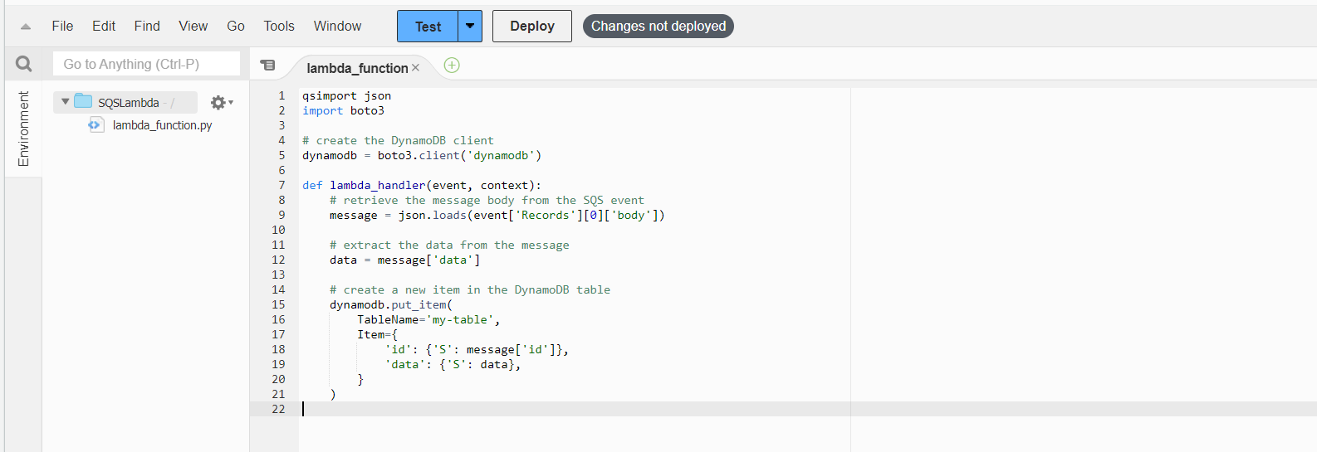

qsimport json

import boto3

# create the DynamoDB client

dynamodb = boto3.client('dynamodb')

def lambda_handler(event, context):

# retrieve the message body from the SQS event

message = json.loads(event['Records'][0]['body'])

# extract the data from the message

data = message['data']

# create a new item in the DynamoDB table

dynamodb.put_item(

TableName='my-table',

Item={

'id': {'S': message['id']},

'data': {'S': data},

}

)

Send message in the queue

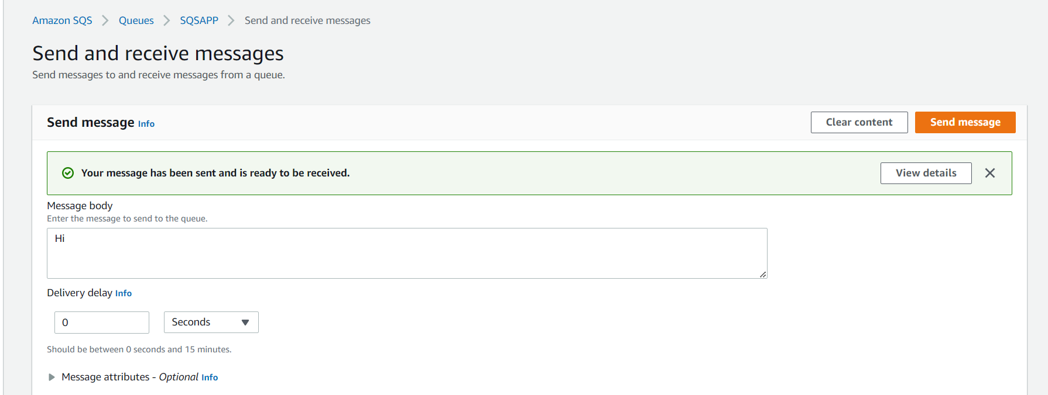

Check in cloudwatch.Received Error.Need to check.

